MULTI-VM DEPARTMENTAL
HOMELAB BUILD
System Administrator Build Documentation — 5 Departments • 18 Virtual Machines • Virtualised Network Segmentation
Platform: Oracle VirtualBox | Servers: Windows Server 2022 | Workstations: Windows 8 | Hypervisor: Type 2

18  Virtual Machines | 5  Departments | 4  Servers (WS2022) | 14  PCs (Windows 8) | 1  Day Build Time

Date: 2 August 2026

Table of Contents
1. Executive Summary3
2. Lab Objectives & Sysadmin Rationale4
3. Network Topology Design (Reference Diagram)5
4. IP Addressing & VM Naming Convention6
5. Host Machine Requirements & Pre-Build Checklist7
6. Software Downloads & Installation8
6.1 Oracle VirtualBox Installation8
6.2 Windows Server 2022 ISO9
6.3 Windows 8 ISO9
7. VM Specifications — Full Inventory10
8. Building the Virtual Machines11
8.1 Finance Department (FIN-SRV-01, FIN-PC-01 to FIN-PC-03)11
8.2 Audit Department (AUD-SRV-01, AUD-PC-01 to AUD-PC-03)14
8.3 IT Department (IT-SRV-01, IT-PC-01 to IT-PC-03)16
8.4 Procurement Department (PRO-SRV-01, PRO-PC-01 to PRO-PC-03)18
8.5 Guest Department (GST-PC-01, GST-PC-02)20
9. VirtualBox Groups — Departmental Organisation21
10. Internal Network Adapter Assignment22
11. Operating System Installation23
11.1 Windows Server 2022 Installation23
11.2 Windows 8 Installation24
12. Post-Build Configuration25
13. Lab Verification & Testing26
14. Snapshot Strategy27

1. Executive Summary
This document is the authoritative build record for a multi-virtual-machine departmental homelab constructed on Oracle VirtualBox. The lab simulates a segmented enterprise network topology across five organisational departments: Finance, Audit, Information Technology, Procurement, and Guest. It was designed and built by a system administrator to replicate the structure, separation, and management characteristics of a production corporate network in a fully virtualised, consequence-free environment.
The lab consists of eighteen virtual machines: four departmental servers running Windows Server 2022, fourteen workstations running Windows 8, and a Guest segment with two workstations and no server. Each department's virtual machines are logically grouped within VirtualBox using the Groups feature, which provides a visual and administrative structure mirroring real-world organisational boundaries. Network isolation is enforced using VirtualBox's Internal Network feature, ensuring that each department's traffic remains within its own broadcast domain.
This homelab serves as a practical platform for system administration skill development and demonstration — providing a hands-on environment for practising Active Directory, Group Policy, user management, network configuration, incident simulation, and security hardening without risk to production systems. Every configuration decision documented here reflects the standards and decision-making processes of a professional system administrator.

2. Lab Objectives & Sysadmin Rationale

2.1 Why Build a Departmental Multi-VM Lab?
A single-machine lab teaches OS installation. A departmental multi-VM lab teaches how systems relate to one another — which is the work of a system administrator. By building separate machines for separate departments, this lab enables practice of the scenarios that define real-world sysadmin work:
- User account management across a multi-department organisation
- Applying different security policies (Group Policy Objects) per department
- Simulating network segmentation and understanding why Finance should not be able to reach Guest network resources
- Server role management — each departmental server is a candidate for DHCP, DNS, file sharing, or domain controller promotion
- Troubleshooting cross-department connectivity and access issues
- Incident response simulation — isolating a compromised department VM without affecting others

2.2 Design Principles
Design Principle | How This Lab Applies It
Separation of Concerns | Each department is an isolated logical unit — separate server, separate workstations, separate internal network. No department shares resources with another by default.
Least-Privilege by Default | Guest department has no server — simulating the real-world restriction that guest/visitor devices should have minimal access and no domain resources.
Realistic Naming Conventions | All VMs follow a structured hostname convention (e.g. FIN-SRV-01, AUD-PC-02) matching enterprise standards — making the lab documentation transferable to real environments.
Scalability | The VirtualBox Groups structure and network design allow new departments or VMs to be added without redesigning the existing topology.
Documentation as a Deliverable | This build document is itself a sysadmin deliverable — demonstrating that configuration decisions were intentional, recorded, and reproducible.

3. Network Topology Design (Reference Diagram)
Figure 1 below is the reference network topology diagram for this lab. It shows the five departmental segments, each represented as a horizontal band with its server and workstations. The blue horizontal lines represent the network boundary between each department — in VirtualBox terms, these are separate Internal Networks, ensuring that VMs in one department cannot communicate directly with VMs in another without routing through a dedicated gateway (a future extension to this lab).

Figure 1 — Departmental Homelab Network Topology (Reference Design)

Finance | 🖥 FIN-SRV-01 | 💻 FIN-PC-01 | 💻 FIN-PC-02 | 💻 FIN-PC-03

Audit | 🖥 AUD-SRV-01 | 💻 AUD-PC-01 | 💻 AUD-PC-02 | 💻 AUD-PC-03

IT Dept. | 🖥 IT-SRV-01 | 💻 IT-PC-01 | 💻 IT-PC-02 | 💻 IT-PC-03

Procurement | 🖥 PRO-SRV-01 | 💻 PRO-PC-01 | 💻 PRO-PC-02 | 💻 PRO-PC-03

Guest | No Server | 💻 GST-PC-01 | 💻 GST-PC-02

Note: Each horizontal blue line in the reference image (see attached Figure 1 — wwww.PNG) represents a separate internal network boundary in VirtualBox. This document recreates that topology programmatically above and uses it as the authoritative design reference for all VM and network configurations that follow.

4. IP Addressing & VM Naming Convention

4.1 Hostname Naming Standard
A structured hostname convention was defined before any VM was created. Consistent naming is a fundamental sysadmin discipline — it enables rapid identification of any machine's department and role from its hostname alone, and aligns with real-world enterprise naming standards.

Hostname Convention: [DEPT-CODE]-[ROLE]-[INDEX]
Format: [3-letter Department Code] - [Role: SRV = Server | PC = Workstation] - [2-digit index]

Examples:
• FIN-SRV-01 = Finance Department, Server 1
• AUD-PC-03 = Audit Department, Workstation 3
• IT-SRV-01 = IT Department, Server 1
• GST-PC-02 = Guest Department, Workstation 2

This convention is consistent with Microsoft naming guidance for Active Directory environments and ensures that VirtualBox Groups, DNS records (if configured), and event logs all use identical identifiers.

4.2 IP Addressing Scheme
A separate /24 subnet was allocated to each department. This mirrors real-world VLAN design where each department operates in its own broadcast domain with a dedicated subnet, enabling per-department firewall rules and access control to be applied in future lab extensions.

Department | Subnet | Subnet Mask | Server IP | PC IP Range
Finance | 192.168.10.0/24 | 255.255.255.240 | 10.0.2.4 | 10.0.2.0/26
Audit | 192.168.20.0/24 | 255.255.255.248 | 10.0.2.3 | 10.0.2.0/26
IT Dept. | 192.168.30.0/24 | 255.255.255.192 | 10.0.2.134 | 10.0.2.0/26
Procurement | 192.168.40.0/24 | 255.255.255.192 | 10.0.2.198 | 10.0.2.0/26
Guest | 192.168.50.0/24 | 255.255.255.0 | N/A (no server) | 10.0.2.0/26

5. Host Machine Requirements & Pre-Build Checklist
Running 18 concurrent virtual machines is resource-intensive. The following specifications and pre-build checks were verified before any VM creation began. A sysadmin never starts a multi-VM build without validating the host can support the intended load.

Component | Minimum Required | Recommended / Used
CPU | Intel/AMD with VT-x / AMD-V enabled in BIOS (required for 64-bit guest OSes) | 8-core or higher — essential for running 18 VMs without critical performance degradation
RAM | 32 GB (absolute minimum for 18 VMs) | 64 GB — allows 2–4 GB per VM with headroom for the host OS
Storage | 500 GB free disk space (dynamically allocated VMs will grow over time) | 1 TB SSD — VMs on SSD vs HDD reduces boot times by ~70% and improves responsiveness
OS | Windows 10/11 or Linux (Ubuntu) as host OS | Windows 11 Pro used as host in this build
VirtualBox | VirtualBox 7.x (latest stable release) | VirtualBox 7.x downloaded from virtualbox.org
Network | Any standard NIC (VirtualBox handles virtualised networking internally) | Single NIC — VirtualBox internal networks are host-independent

5.1 RAM Allocation Plan (18 VMs)
RAM Allocation Strategy — Avoid Host Starvation
Total lab RAM budget: ~24 GB (leaving ~8 GB for host OS on a 32 GB machine)

• FIN-SRV-01: 4 GB (Windows Server 2022 needs minimum 2 GB; 4 GB recommended)
• AUD-SRV-01: 4 GB
• IT-SRV-01: 4 GB
• PRO-SRV-01: 4 GB
• 14 × Win8 PCs: 1 GB each = 14 GB
• Total: 30 GB (not all VMs run simultaneously — run 1–2 departments at a time)

Sysadmin Note: Running all 18 VMs simultaneously is only feasible on 64 GB RAM. For a 32 GB host, operate one department group at a time. VirtualBox's Groups feature makes this straightforward — power on/off entire groups with one click.

6. Software Downloads & Installation

6.1 Oracle VirtualBox Installation
VirtualBox is the Type 2 hypervisor (hosted hypervisor) that provides the virtualisation layer for this entire lab. It was downloaded from the official Oracle website to ensure authenticity and to receive the latest version with current guest OS support.

- Navigated to https://www.virtualbox.org/wiki/Downloads
- Selected the platform package for the host OS (Windows hosts for a Windows 11 host machine)
- Downloaded the VirtualBox installer (VirtualBox-[version]-Win.exe)
- Also downloaded the VirtualBox Extension Pack from the same page — provides USB 2.0/3.0, RDP, and disk encryption support
- Ran the VirtualBox installer as Administrator — accepted all default settings
- After VirtualBox installation completed, ran the Extension Pack installer — accepted the Oracle VirtualBox Extension Pack License Agreement
- Launched VirtualBox — confirmed the Manager window opened with no VMs listed (clean state)

📷 [ SCREENSHOT ]
VirtualBox — First Launch (Manager Window, No VMs)
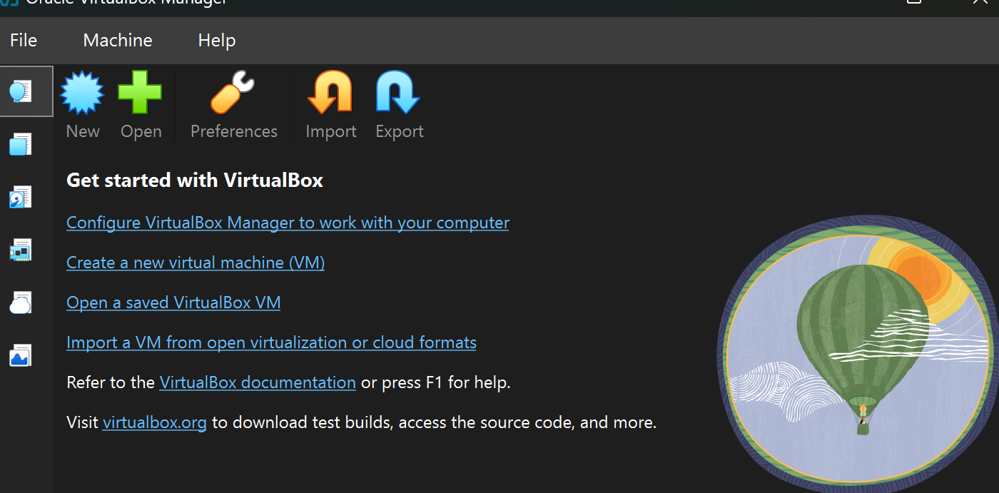

6.2 Windows Server 2022 ISO
Windows Server 2022 provides the operating system for the four departmental servers. The evaluation ISO was obtained directly from Microsoft — no licence key is required for the 180-day evaluation period, which is more than sufficient for a homelab environment.

- Navigated to https://www.microsoft.com/en-us/evalcenter/download-windows-server-2022
- Selected ISO download, filled in the registration form (name, email, company)
- Selected English (United States) and 64-bit edition
- Downloaded the ISO file: SERVER_EVAL_x64FRE_en-us_OEM.iso (approximately 5.0 GB)
- Verified the file downloaded completely by checking the file size matched the listed download size

6.3 Windows 8 ISO
Windows 8 was selected for the workstation VMs. As a lighter-weight OS compared to Windows 10/11, it reduces RAM and disk consumption per VM — important when running 14 workstations. The ISO was sourced from a legitimate Microsoft archive.

- Sourced the Windows 8 x64 ISO from the Microsoft Software Download centre or a legitimate ISO archive
- Downloaded the ISO file: Win8_[edition]_English_x64.iso (approximately 3.0–3.5 GB)
- Stored both ISOs in a dedicated folder: C:\VM-ISOs\ (or equivalent) for easy access during VM creation

📷 [ SCREENSHOT ]
ISO Files — Both ISOs in the VM-ISOs Folder

7. VM Specifications — Full Inventory
The following table is the complete VM inventory for the homelab. These specifications were determined before any VM was created and serve as the build reference throughout Sections 8–9. All VMs use dynamically allocated storage to conserve host disk space.

Hostname | Role | OS | RAM | CPU | Disk | VirtualBox Group
FIN-SRV-01 | Dept. Server | Windows Server 2022 | 8129 MB | 8 | 80.76 GB | Finance/Finance-Server
FIN-PC-01 | Workstation | Windows 8 | 4096 MB | 4 | 40.54 GB | Finance/Finance-PCs
FIN-PC-02 | Workstation | Windows 8 | 4096MB | 4 | 40 GB | Finance/Finance-PCs
FIN-PC-03 | Workstation | Windows 8 | 4096 MB | 4 | 40 GB | Finance/Finance-PCs
AUD-SRV-01 | Dept. Server | Windows Server 2022 | 4096 MB | 4 | 80.76 GB | Audit/Audit-Server
AUD-PC-01 | Workstation | Windows 8 | 4096 MB | 4 | 40 GB | Audit/Audit-PCs
AUD-PC-02 | Workstation | Windows 8 | 4096 MB | 4 | 40 GB | Audit/Audit-PCs
AUD-PC-03 | Workstation | Windows 8 | 4096MB | 4 | 40 GB | Audit/Audit-PCs
IT-SRV-01 | Dept. Server | Windows Server 2022 | 4096 MB | 4 | 50 GB | IT-Dept/IT-Server
IT-PC-01 | Workstation | Windows 8 | 4096 MB | 4 | 40 GB | IT-Dept/IT-PCs
IT-PC-02 | Workstation | Windows 8 | 4096 MB | 4 | 40 GB | IT-Dept/IT-PCs
IT-PC-03 | Workstation | Windows 8 | 4096 MB | 4 | 40 GB | IT-Dept/IT-PCs
PRO-SRV-01 | Dept. Server | Windows Server 2022 | 4096 MB | 4 | 50 GB | Procurement/PRO-Server
PRO-PC-01 | Workstation | Windows 8 | 4096 MB | 4 | 40 GB | Procurement/PRO-PCs
PRO-PC-02 | Workstation | Windows 8 | 4096 MB | 4 | 40 GB | Procurement/PRO-PCs
PRO-PC-03 | Workstation | Windows 8 | 4096 MB | 4 | 40 GB | Procurement/PRO-PCs
GST-SVR-01 | Dept. Server | Windows Server 2022 | 4096 MB | 4 | 50 GB | Guest/Guest-Server
GST-PC-01 | Workstation | Windows 8 | 4096 MB | 4 | 40 GB | Guest/Guest-PCs
GST-PC-02 | Workstation | Windows 8 | 4096 MB | 4 | 40 GB | Guest/Guest-PCs

8. Building the Virtual Machines
All VMs were created using the VirtualBox New VM Wizard. The procedure below is documented once in full for the Finance department (as the template), with abbreviated records for the remaining departments noting only the values that differ. This mirrors real sysadmin documentation practice — establish the standard once, then record deviations.

• Finance Department | 4 VMs VMs total | 1 Server | 3 Workstations

8.1 Finance Department VMs

FIN-SRV-01 — Finance Department Server
- In VirtualBox Manager, clicked Machine > New (or Ctrl+N)
- Name: FIN-SRV-01 | Folder: [choose a dedicated VM storage folder e.g. D:\VMs\Finance\]
- ISO Image: Selected the Windows Server 2022 ISO from C:\VM-ISOs\
- Edition: Windows Server 2022 Standard (Desktop Experience) — checked 'Skip Unattended Installation'
- Hardware: RAM = 4096 MB | Processors = 2 vCPUs
- Hard Disk: Create a Virtual Hard Disk Now | Size = 60 GB | VDI | Dynamically Allocated
- Clicked Finish — VM appeared in the VirtualBox Manager list
- Right-clicked FIN-SRV-01 > Settings > System > Boot Order: set Optical first, then Hard Disk
- Settings > Display > Video Memory: set to 128 MB
- Settings > Network > Adapter 1: Attached to = Internal Network | Name = Finance-Net

📷 [ SCREENSHOT ]
VirtualBox — FIN-SRV-01 VM Summary Screen (After Creation)
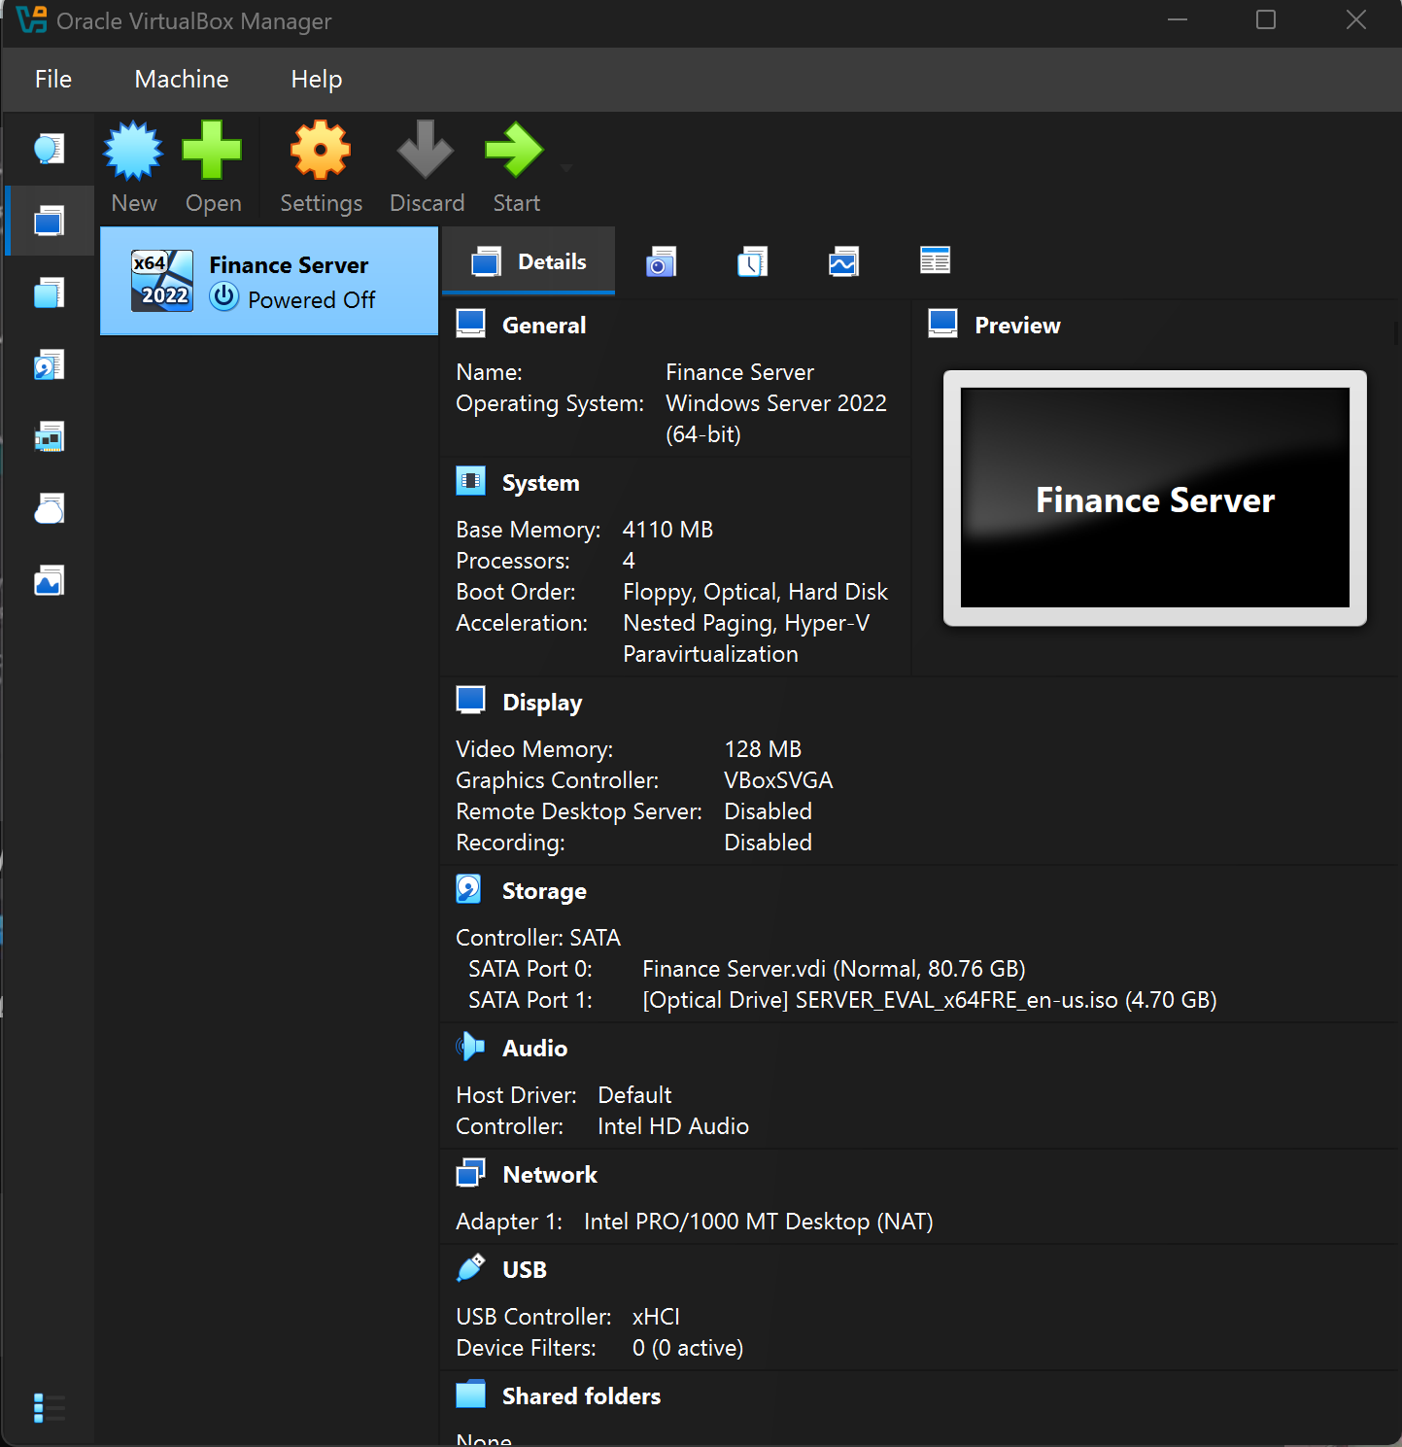

📷 [ SCREENSHOT ]
VirtualBox — FIN-SRV-01 Settings: Network Tab
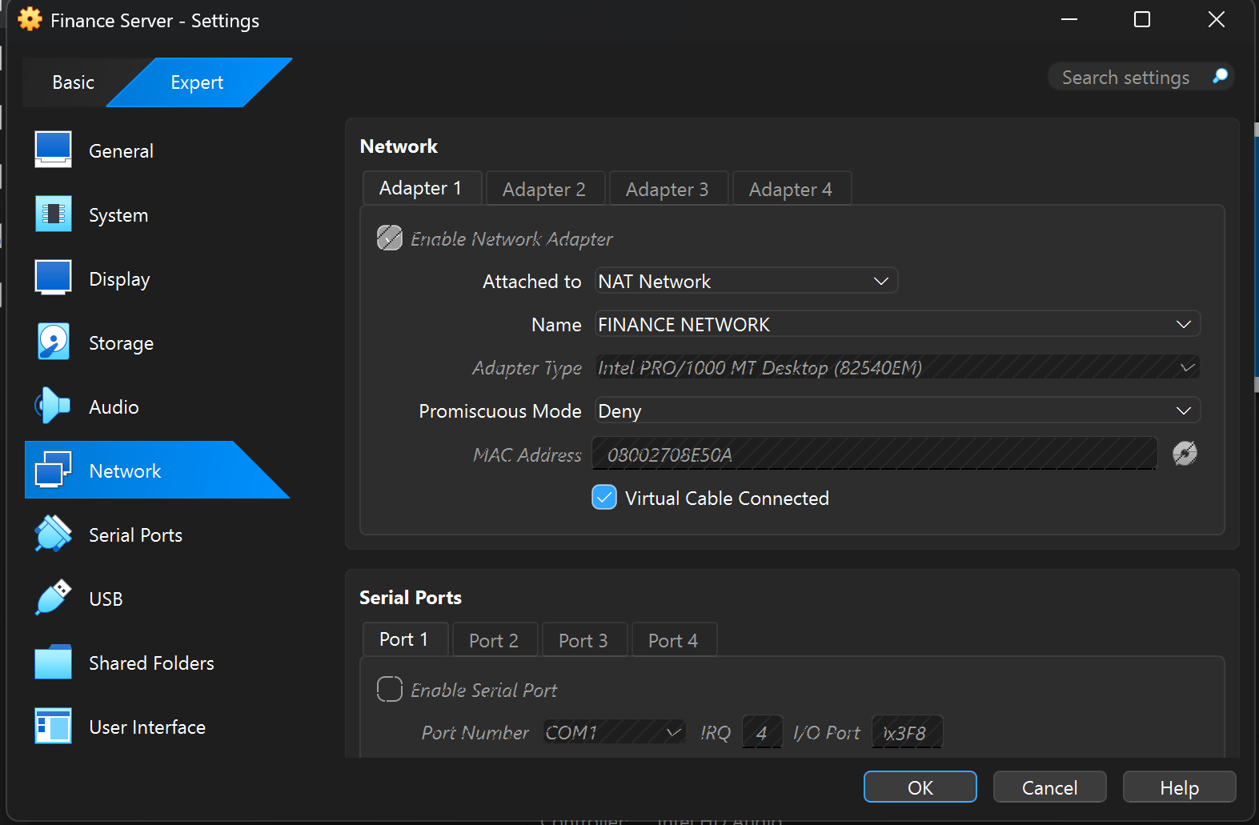

FIN-PC-01, FIN-PC-02, FIN-PC-03 — Finance Workstations
The three Finance workstations were created using the same procedure as FIN-SRV-01 with the following differences:
Setting | FIN-PC-01 | FIN-PC-02 | FIN-PC-03
Name | FIN-PC-01 | FIN-PC-02 | FIN-PC-03
ISO | Windows 8 x64 | Windows 8 x64 | Windows 8 x64
RAM | 4096 MB | 4096 MB | 4096 MB
vCPUs | 4 | 4 | 4
Disk | 40 GB VDI Dyn. | 40 GB VDI Dyn. | 40 GB VDI Dyn.
Network | Finance-Net | Finance-Net | Finance-Net

📷 [ SCREENSHOT ]
VirtualBox — All Three Finance PCs Listed (FIN-PC-01, 02, 03)
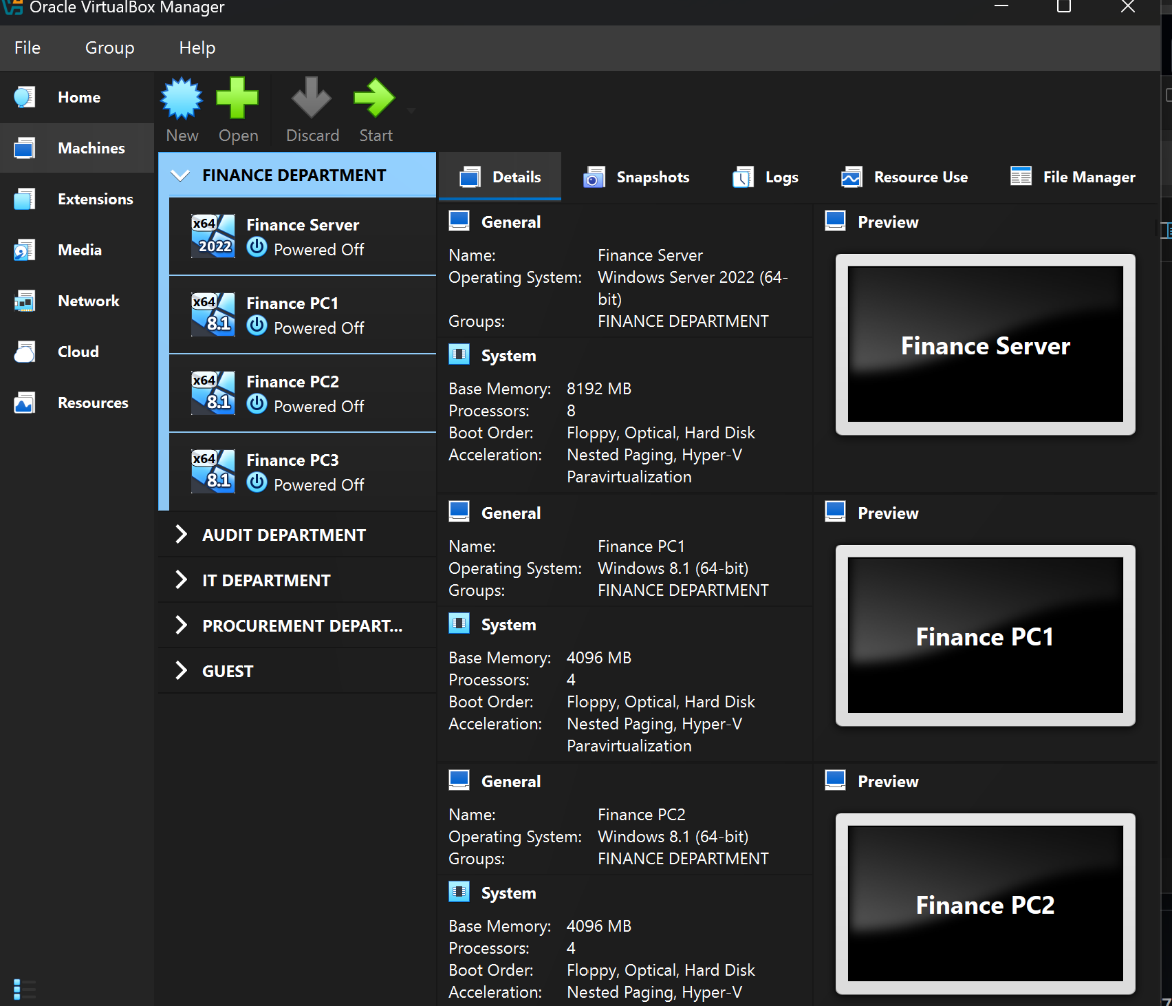

• Audit Department | 4 VMs VMs total | 1 Server | 3 Workstations

8.2 Audit Department VMs
All four Audit VMs were created following the identical procedure established in Section 8.1, substituting Audit-specific values. The key distinction is the Internal Network name — all Audit VMs connect to Audit-Net, not Finance-Net, ensuring complete isolation between the two departments.

Setting | AUD-SRV-01 | AUD-PC-01 | AUD-PC-02 | AUD-PC-03
OS | Windows Server 2022 | Windows 8 | Windows 8 | Windows 8
RAM | 4096 MB | 4096 MB | 4096 MB | 4096 MB
vCPUs | 4 | 4 | 4 | 4
Disk | 50 GB VDI Dyn. | 40 GB VDI | 40 GB VDI | 40 GB VDI
Network | Audit-Net | Audit-Net | Audit-Net | Audit-Net

📷 [ SCREENSHOT ]
VirtualBox — AUD-SRV-01 Settings: Network Adapter (Audit-Net)
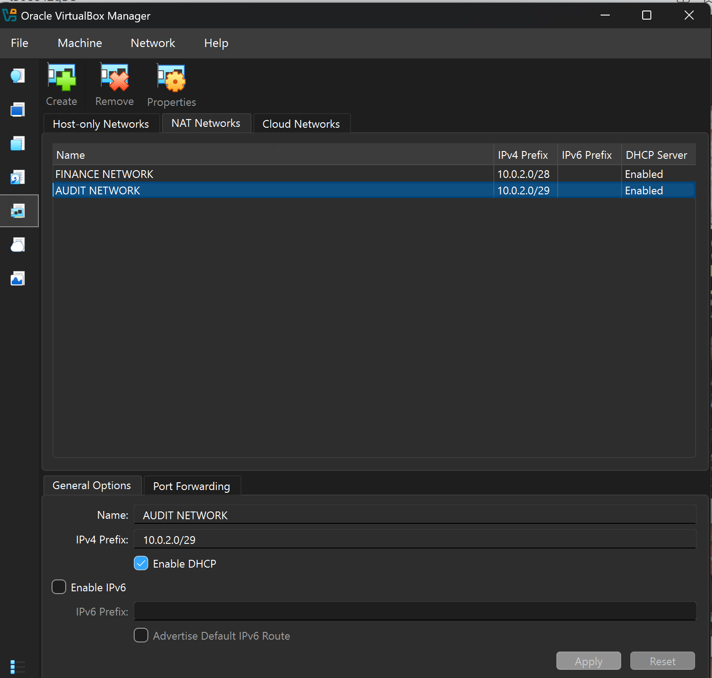Capture the VM Settings > Network tab for AUD-SRV-01 showing Internal Network name = 'Audit-Net'. This confirms the Audit server is isolated to its own network segment, separate from Finance-Net.

• IT Dept. Department | 4 VMs VMs total | 1 Server | 3 Workstations

8.3 IT Department VMs
The IT Department VMs follow the same build pattern. As the IT department is the team responsible for managing the other departments' systems in a real-world organisation, IT-SRV-01 is configured with 2 vCPUs and 4 GB RAM — identical to the other servers — and will connect to IT-Net. In a future lab extension, IT-SRV-01 would be promoted to a Domain Controller, providing authentication services for the entire organisation.

Setting | IT-SRV-01 | IT-PC-01 | IT-PC-02 | IT-PC-03
OS | Windows Server 2022 | Windows 8 | Windows 8 | Windows 8
RAM | 4096 MB | 4096 MB | 4096 MB | 4096 MB
vCPUs | 4 | 4 | 4 | 4
Disk | 50 GB VDI Dyn. | 40 GB VDI | 40 GB VDI | 40 GB VDI
Network | IT-Net | IT-Net | IT-Net | IT-Net

📷 [ SCREENSHOT ]
VirtualBox — IT Department VMs Created (IT-SRV-01, IT-PC-01, IT-PC-02, IT-PC-03)
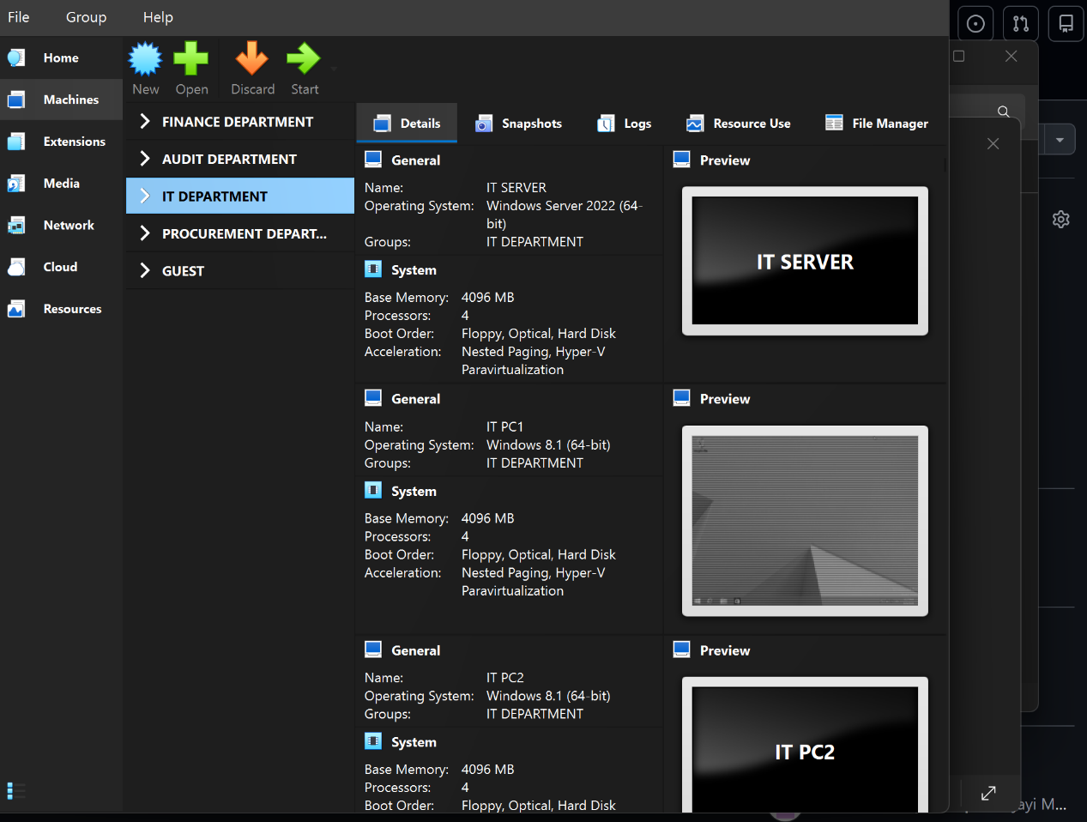

• Procurement Department | 4 VMs VMs total | 1 Server | 3 Workstations

8.4 Procurement Department VMs
The Procurement department VMs are built identically to the Finance and Audit departments with Procurement-specific hostnames and the Procurement-Net internal network name. Procurement handles supplier management and contract data — in a real environment, access from Guest to Procurement data would be strictly blocked.

Setting | PRO-SRV-01 | PRO-PC-01 | PRO-PC-02 | PRO-PC-03
OS | Windows Server 2022 | Windows 8 | Windows 8 | Windows 8
RAM | 4096 MB | 4096 MB | 4096 MB | 4096 MB
vCPUs | 4 | 4 | 4 | 4
Disk | 50 GB VDI Dyn. | 40 GB VDI | 40 GB VDI | 40 GB VDI
Network | Procurement-Net | Procurement-Net | Procurement-Net | Procurement-Net

📷 [ SCREENSHOT ]
VirtualBox — PRO-SRV-01 Settings Summary
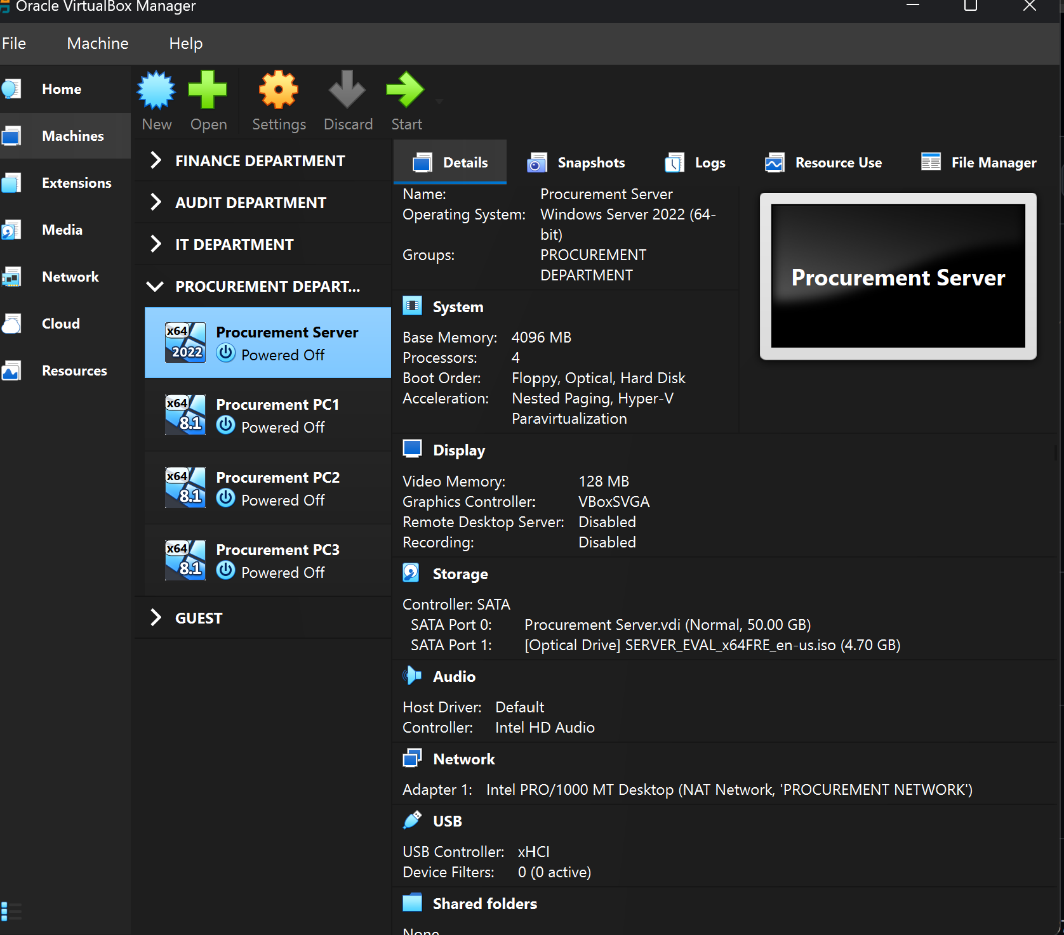

• Guest Department | 2 VMs VMs total | 0 Server | 2 Workstations

8.5 Guest Department VMs
The Guest department is intentionally limited to two workstations with no departmental server. This is a deliberate security design decision, not an oversight. Guest users — visitors, contractors, or temporary staff — should have no access to domain resources, file servers, or internal services. By providing no server in the Guest segment, the design enforces this principle at the infrastructure level.

Sysadmin Design Decision — Why Guest Has No Server
In enterprise networks, Guest VLANs are typically restricted to internet access only — no domain join, no file share access, no internal DNS resolution. A server in the Guest segment would imply domain services, which contradicts this principle.

By omitting a server from the Guest department in this lab, the design correctly reflects real-world network segmentation policy. Guest VMs (GST-PC-01 and GST-PC-02) connect to Guest-Net and operate as standalone machines with no domain authentication.

In a future lab extension, a pfSense or Windows firewall VM could be added to the Guest network boundary to enforce strict outbound-only internet access — the architecture already supports this.

Setting | GST-PC-01 | GST-PC-02
OS | Windows 8 x64 | Windows 8 x64
RAM | 4096 MB | 4096 MB
vCPUs | 4 | 4
Disk | 25 GB VDI Dyn. | 25 GB VDI Dyn.
Network | Guest-Net | Guest-Net

📷 [ SCREENSHOT ]
VirtualBox — GST-PC-01 and GST-PC-02 Created (Guest Department)
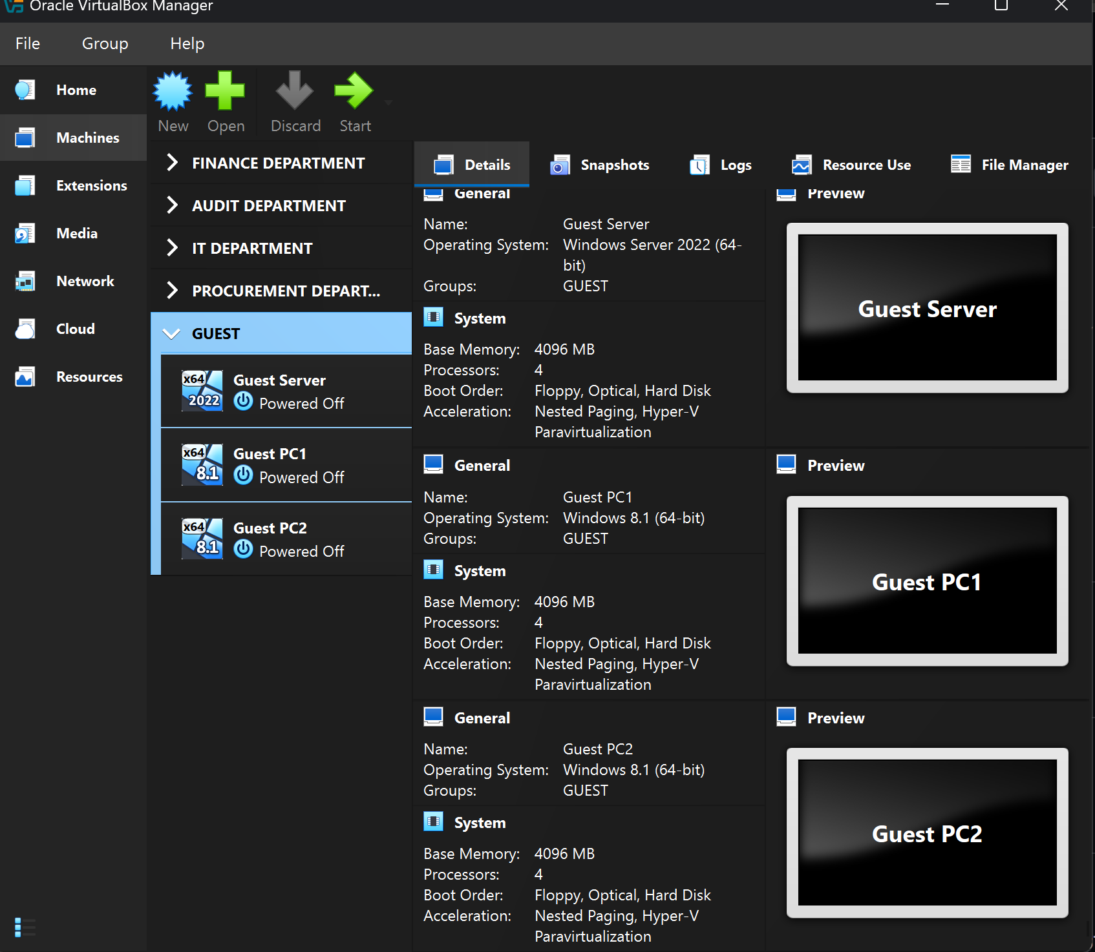

9. VirtualBox Groups — Departmental Organisation
After all 18 VMs were created, they were organised into VirtualBox Groups. Groups in VirtualBox provide a hierarchical, folder-like structure in the Manager's left panel — allowing VMs to be visually and administratively organised by department. This is one of the most important quality-of-life features for managing a large homelab and is directly analogous to Organisational Units (OUs) in Active Directory.

9.1 Group Structure
Group Name | Sub-Group | VMs in Group
Finance | Finance-Server | FIN-SRV-01
 | Finance-PCs | FIN-PC-01, FIN-PC-02, FIN-PC-03
Audit | Audit-Server | AUD-SRV-01
 | Audit-PCs | AUD-PC-01, AUD-PC-02, AUD-PC-03
IT-Dept | IT-Server | IT-SRV-01
 | IT-PCs | IT-PC-01, IT-PC-02, IT-PC-03
Procurement | PRO-Server | PRO-SRV-01
 | PRO-PCs | PRO-PC-01, PRO-PC-02, PRO-PC-03
Guest | Guest-PCs | GST-PC-01, GST-PC-02

9.2 Creating Groups in VirtualBox
- In VirtualBox Manager, selected FIN-SRV-01, then held Ctrl and selected FIN-PC-01, FIN-PC-02, FIN-PC-03
- Right-clicked the selection > Move to Group > New Group — a group was created, renamed to 'Finance'
- Within the Finance group, right-clicked FIN-SRV-01 > Move to Group > New Group — named 'Finance-Server'
- Right-clicked FIN-PC-01, FIN-PC-02, FIN-PC-03 (selected together) > Move to Group > New Group — named 'Finance-PCs'
- Repeated the entire process for Audit, IT-Dept, Procurement, and Guest departments
- Collapsed all groups using the arrow icons to verify the clean 5-group top-level view matched the reference topology

📷 [ SCREENSHOT ]
VirtualBox Manager — Full Departmental Group Structure (All Groups Expanded)
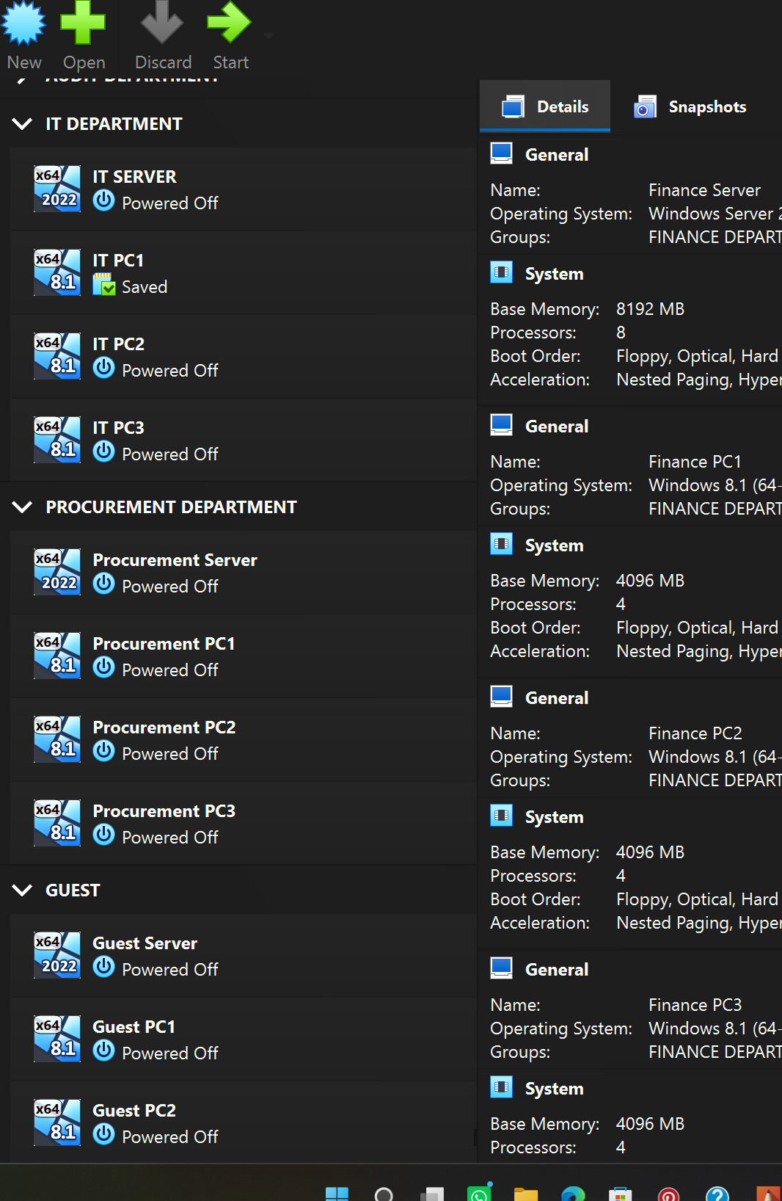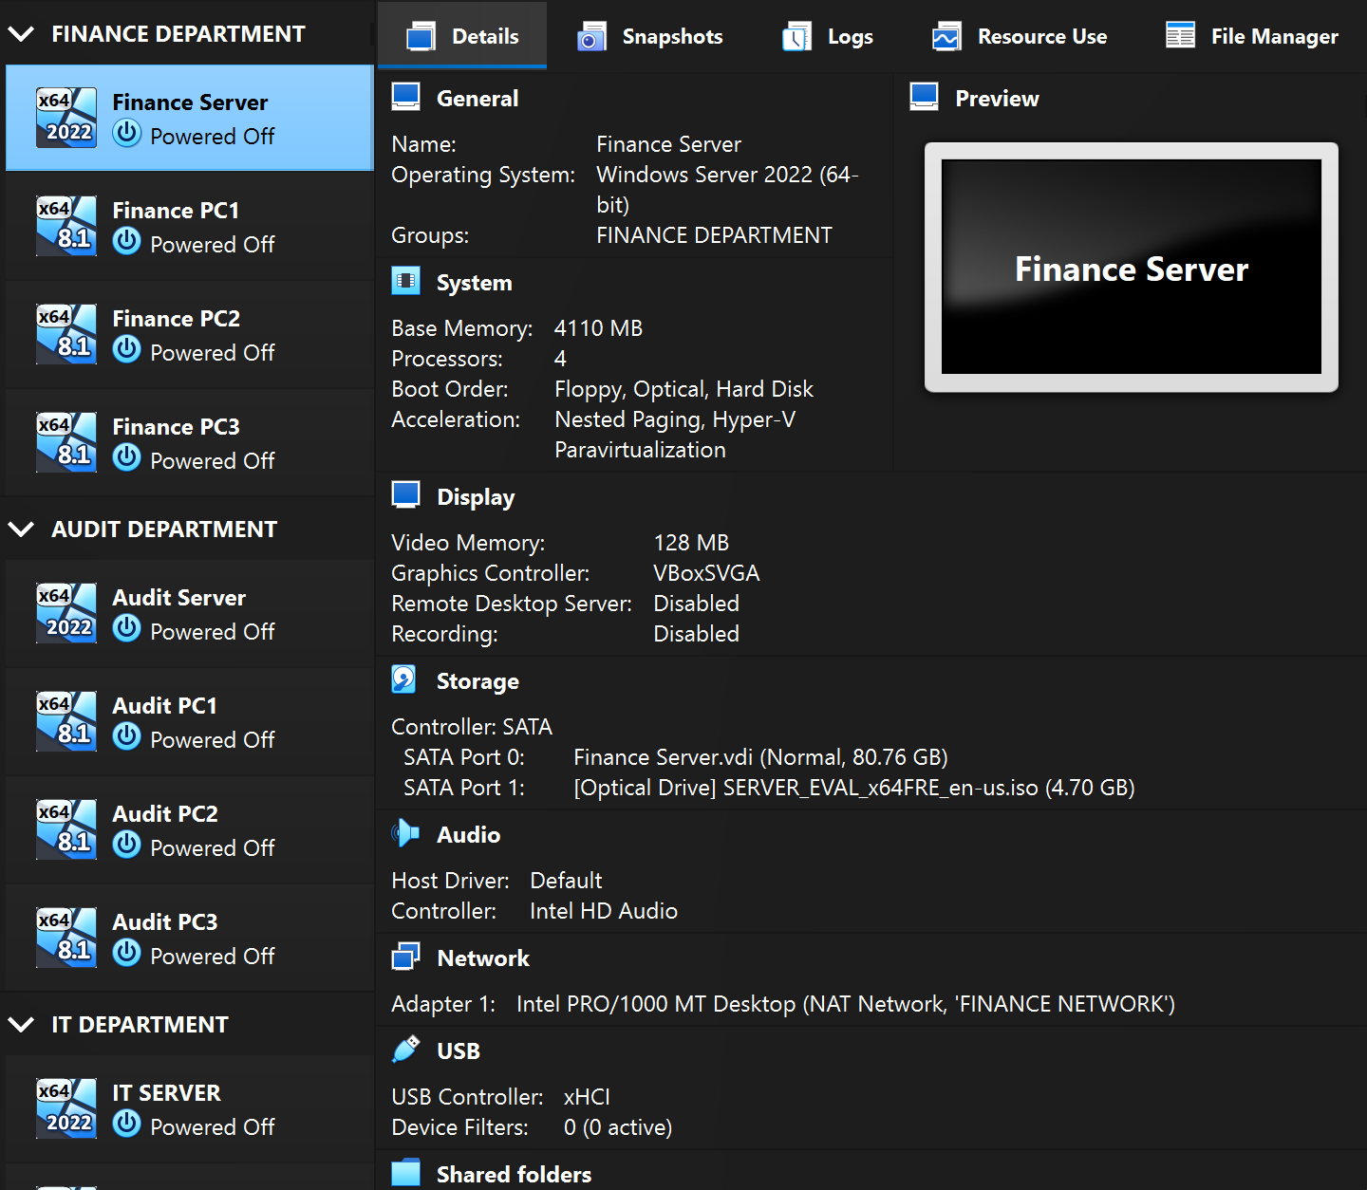

📷 [ SCREENSHOT ]
VirtualBox Manager — Groups Collapsed (Top-Level View)
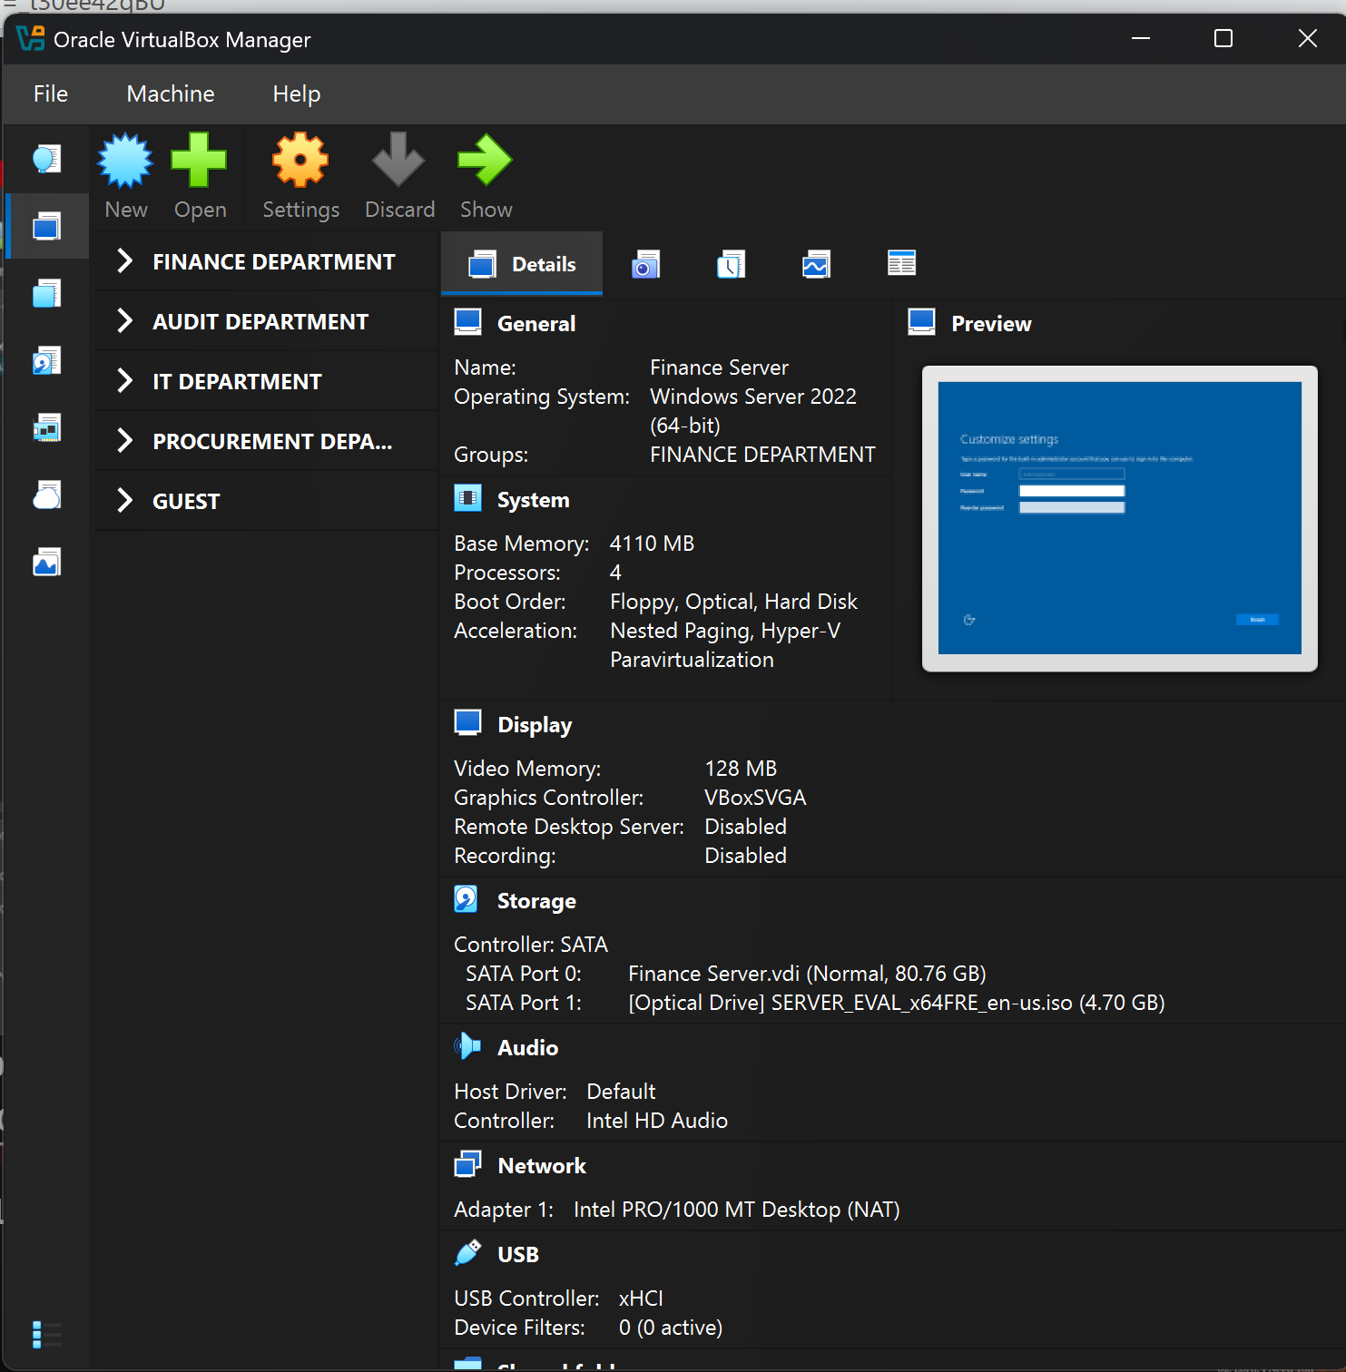

10. Internal Network Adapter Assignment
Every VM's network adapter was verified to be attached to the correct Internal Network. This is the critical configuration step that enforces departmental isolation — a VM on Finance-Net cannot receive packets from or send packets to a VM on Audit-Net, regardless of IP configuration, because VirtualBox Internal Networks are completely isolated Layer 2 broadcast domains.

Hostname | Department | Internal Network Name | Adapter Type | Status
FIN-SRV-01 | Finance | Finance-Net | Intel PRO/1000 MT Desktop | Assigned ✓
FIN-PC-01 | Finance | Finance-Net | Intel PRO/1000 MT Desktop | Assigned ✓
FIN-PC-02 | Finance | Finance-Net | Intel PRO/1000 MT Desktop | Assigned ✓
FIN-PC-03 | Finance | Finance-Net | Intel PRO/1000 MT Desktop | Assigned ✓
AUD-SRV-01 | Audit | Audit-Net | Intel PRO/1000 MT Desktop | Assigned ✓
AUD-PC-01 | Audit | Audit-Net | Intel PRO/1000 MT Desktop | Assigned ✓
AUD-PC-02 | Audit | Audit-Net | Intel PRO/1000 MT Desktop | Assigned ✓
AUD-PC-03 | Audit | Audit-Net | Intel PRO/1000 MT Desktop | Assigned ✓
IT-SRV-01 | IT Dept. | IT-Net | Intel PRO/1000 MT Desktop | Assigned ✓
IT-PC-01 | IT Dept. | IT-Net | Intel PRO/1000 MT Desktop | Assigned ✓
IT-PC-02 | IT Dept. | IT-Net | Intel PRO/1000 MT Desktop | Assigned ✓
IT-PC-03 | IT Dept. | IT-Net | Intel PRO/1000 MT Desktop | Assigned ✓
PRO-SRV-01 | Procurement | Procurement-Net | Intel PRO/1000 MT Desktop | Assigned ✓
PRO-PC-01 | Procurement | Procurement-Net | Intel PRO/1000 MT Desktop | Assigned ✓
PRO-PC-02 | Procurement | Procurement-Net | Intel PRO/1000 MT Desktop | Assigned ✓
PRO-PC-03 | Procurement | Procurement-Net | Intel PRO/1000 MT Desktop | Assigned ✓
GST-PC-01 | Guest | Guest-Net | Intel PRO/1000 MT Desktop | Assigned ✓
GST-PC-02 | Guest | Guest-Net | Intel PRO/1000 MT Desktop | Assigned ✓

11. Operating System Installation

11.1 Windows Server 2022 Installation (All 4 Servers)
The following procedure was followed for each of the four departmental servers (FIN-SRV-01, AUD-SRV-01, IT-SRV-01, PRO-SRV-01). OS installation was performed on each VM sequentially.

- Started the VM (double-click or Start button) — it booted from the attached Windows Server 2022 ISO
- Windows Setup loaded. Selected: Language = English (United States) | Time = English (UK) | Keyboard = US
- Clicked Install Now
- Selected edition: Windows Server 2022 Standard Evaluation (Desktop Experience) — GUI version
- Accepted the Microsoft Software License Terms
- Selected Custom: Install Windows only (advanced) — fresh installation, no upgrade
- Selected the 60 GB virtual disk and clicked Next — installation began
- Windows installed and rebooted automatically (2–3 reboots during installation)
- Set the built-in Administrator password on first boot prompt
- Windows Server 2022 Desktop loaded with Server Manager launching automatically
- Renamed the computer: Server Manager > Local Server > Computer name > Change — set to the VM's hostname (e.g. FIN-SRV-01)
- Rebooted to apply the hostname change

📷 [ SCREENSHOT ]
Windows Server 2022 — Edition Selection Screen

📷 [ SCREENSHOT ]
PRO-SRV-01 — Server Manager Dashboard (After Rename)
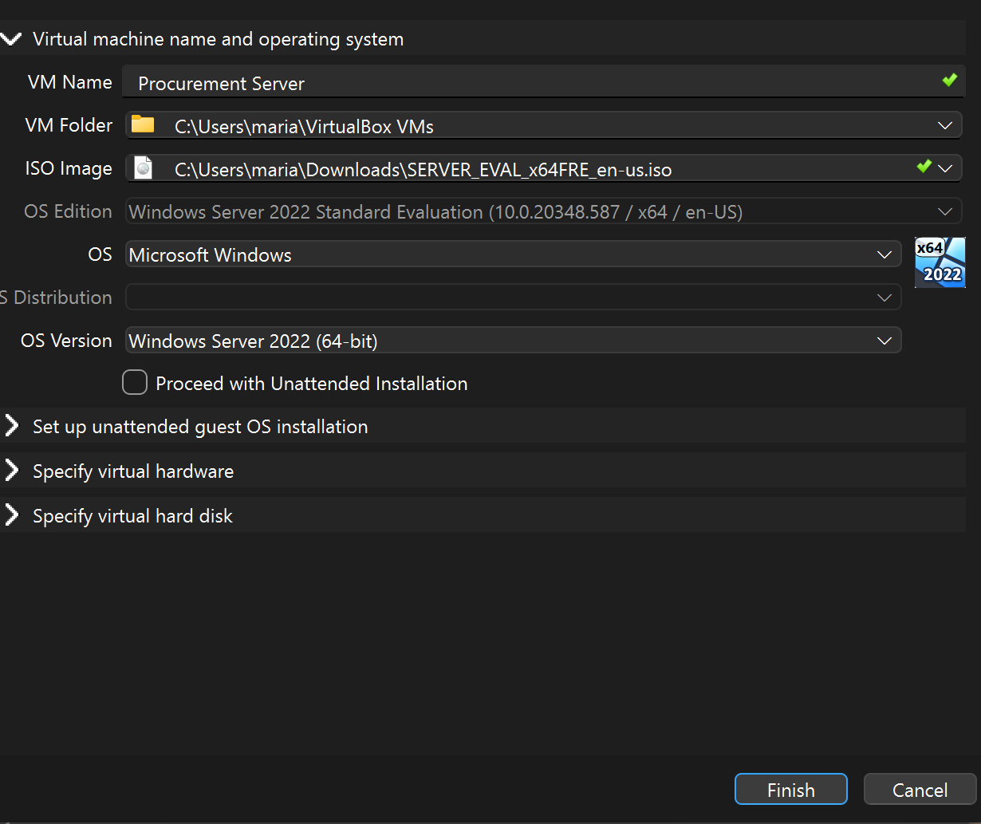

11.2 Windows 8 Installation (All 14 Workstations)
The following procedure was followed for each Windows 8 workstation VM. The process is faster than Server 2022 installation due to the lighter OS footprint.

- Started the workstation VM — booted from the attached Windows 8 ISO
- Windows Setup loaded — selected Language, Time, and Keyboard settings
- Clicked Install Now
- Entered the product key if required, or selected 'I don't have a product key' for evaluation use
- Accepted the licence terms and selected Custom installation
- Selected the 25 GB virtual disk — installation began
- Windows 8 installed and rebooted — completed the OOBE (Out-of-Box Experience): created a local user account (no Microsoft account)
- Renamed the PC via Control Panel > System > Change settings — set to the VM's hostname (e.g. FIN-PC-01)
- Rebooted to apply the hostname change

📷 [ SCREENSHOT ]
Windows 8 — Desktop After Installation (Example: FIN-PC-01)
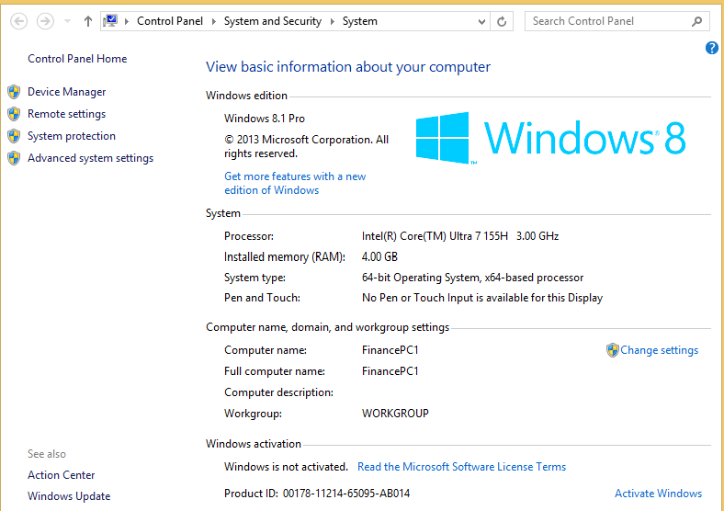

12. Post-Build Configuration
After all 18 VMs were built and their operating systems installed, the following post-build configurations were applied. These steps represent the minimum sysadmin configuration required to make each VM functional within its departmental network.

12.1 Server Post-Build Steps (Applied to All 4 Servers)
- Set static IP address matching the IP scheme in Section 4.2 (e.g. FIN-SRV-01 = 10.0.2.4)
- Set DNS server to the server's own IP (preparing for future DNS role installation)
- Enabled Remote Desktop via Server Manager > Local Server > Remote Desktop = Enabled
- Applied all available Windows Updates to patch the evaluation installation
- Set Windows Firewall to allow ICMP (ping) — enables network connectivity testing between VMs in the same segment
- Installed VirtualBox Guest Additions (Devices menu > Insert Guest Additions CD) for improved display and shared clipboard
- Took a clean-state snapshot (Section 14)

12.2 Workstation Post-Build Steps (Applied to All 14 PCs)
- Set static IP address matching the subnet for the PC's department (e.g. FIN-PC-01 = 10.0.2.2, FIN-PC-02 = 10.0.2.6, FIN-PC-03 = 10.0.2.5)
- Set Default Gateway to the server IP for the department (preparing for future routing configuration)
- Installed VirtualBox Guest Additions for display and clipboard support
- Disabled Windows Defender (optional in lab environment to reduce overhead)
- Confirmed network connectivity to the departmental server using ping
- Took a clean-state snapshot

📷 [ SCREENSHOT ]
Windows 8 — Static IP Configuration (FIN-PC-01 Example)
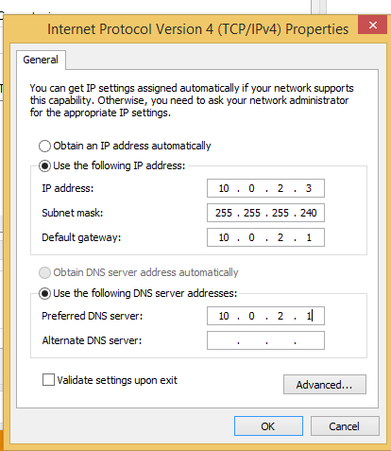

13. Lab Verification & Testing
After all VMs were configured, a structured set of connectivity tests was performed to verify that the internal network segmentation was functioning correctly. Passing all tests confirms that: intra-department VMs can communicate, and inter-department VMs cannot (without a router — isolation confirmed).

13.1 Intra-Department Tests (Expected: PASS)
From VM | To VM | Command | Expected
FIN-PC-01 (10.101) | FIN-SRV-01 (10.10) | ping 10.0.2.4 | Reply — PASS ✓
AUD-PC-01 (20.101) | AUD-SRV-01 (20.10) | ping 10.0.2.3 | Reply — PASS ✓
IT-PC-01 (30.101) | IT-SRV-01 (30.10) | ping 10.0.2.134 | Reply — PASS ✓
PRO-PC-01 (40.101) | PRO-SRV-01 (40.10) | ping 10.0.2.198 | Reply — PASS ✓
GST-PC-01 (50.101) | GST-SVR-02 (50.102) | ping 10.0.2.15 | Reply — PASS ✓

13.2 Inter-Department Tests (Expected: FAIL — Isolation Confirmed)
From VM | To VM | Command | Expected
FIN-PC-01 (10.101) | AUD-SRV-01 (20.10) | ping 10.0.2.3 | Timeout — ISOLATED ✓
IT-PC-01 (30.101) | FIN-SRV-01 (10.10) | ping 10.0.2.4 | Timeout — ISOLATED ✓
GST-PC-01 (50.101) | PRO-SRV-01 (40.10) | ping 10.0.2.198 | Timeout — ISOLATED ✓

📷 [ SCREENSHOT ]
CMD — Intra-Department Ping (FIN-PC-01 to FIN-SRV-01, PASS)
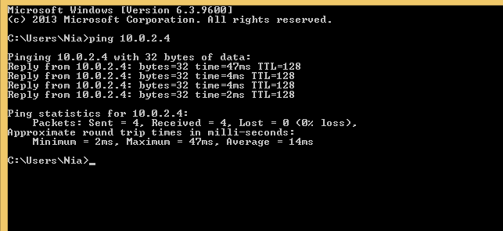

📷 [ SCREENSHOT ]
CMD — Inter-Department Ping (FIN-PC-01 to IT-SRV-01, ISOLATED)
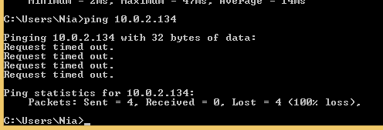

14. Snapshot Strategy
Taking snapshots at strategic points is one of the most important practices in homelab management. Snapshots allow you to revert a VM to a known-good state after a failed configuration, a simulated attack, or an OS error — without rebuilding the VM from scratch. A sysadmin without a snapshot strategy will eventually lose hours of work to a single bad configuration change.

Snapshot Name | Taken When | Purpose
Clean-OS-Install | Immediately after OS installation and hostname rename, before any configuration changes | Baseline — revert here if OS config is corrupted
Post-Static-IP | After static IP, DNS, and Remote Desktop are configured and verified working | Network baseline — working intra-dept connectivity confirmed
Post-Guest-Additions | After VirtualBox Guest Additions successfully installed | Display and clipboard sharing working
Post-Windows-Update | After all Windows Updates applied | Patched baseline — start future exercises from here
Pre-Experiment-[Name] | Before starting any new configuration exercise or simulated scenario | Safety net — always revert to this before a new experiment

Multi-VM Departmental Homelab | VirtualBox | Windows Server 2022 | Windows 8 | 18 VMs | 5 Departments

